Frame format for 11n
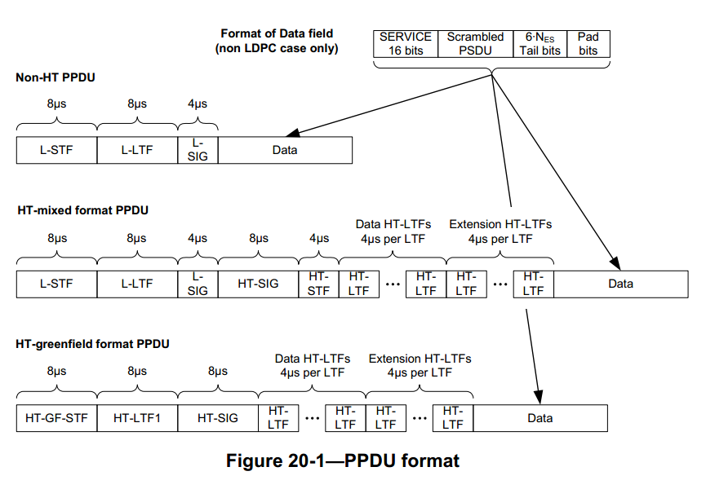

The structure of the PPDU transmitted is determined by the TXVECTOR FORMAT, CH_BANDWIDTH, CH_OFFSET, and MCS parameter.
The FORMAT parameter determines the overall structure of PPDU including NON_HT, HT_MF and HT_GF. HT_MF and HT_GF also called HT format. The figure 20-1 shows the NON-HT format and the HT format.

Transmitter block diagram
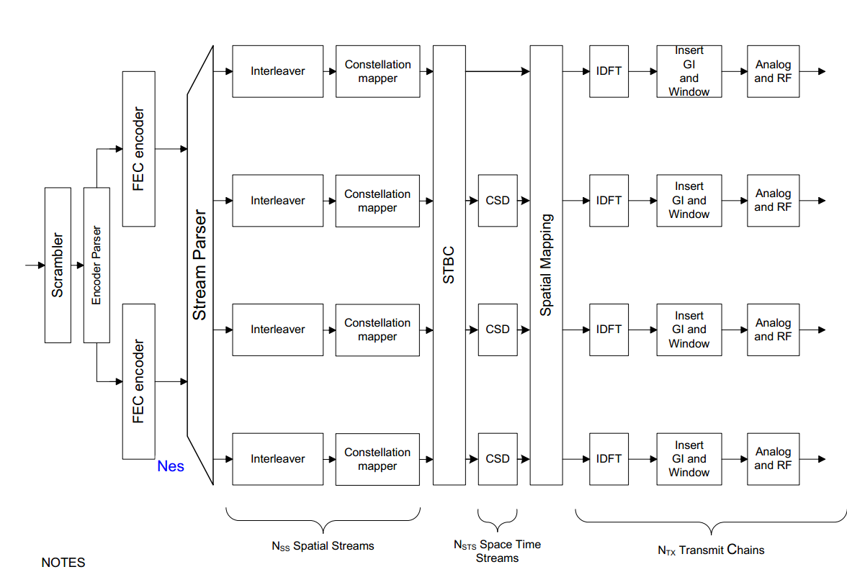

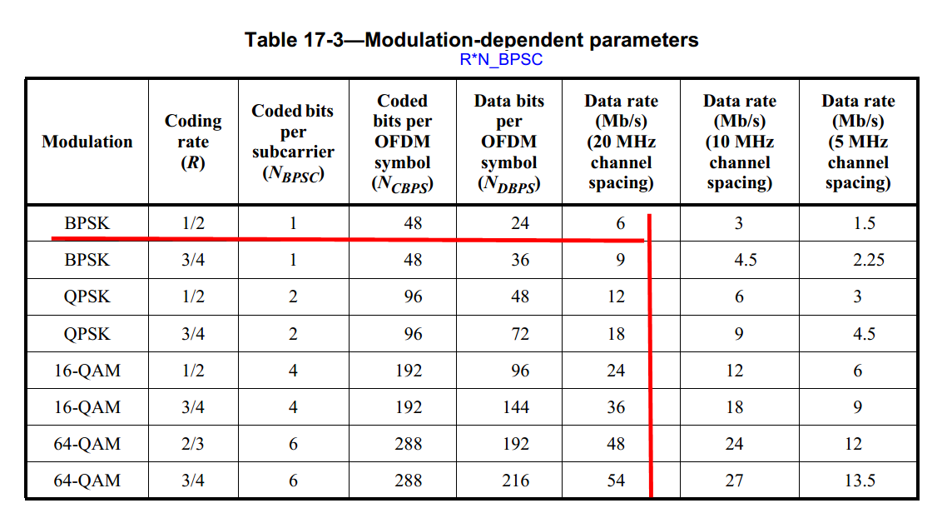

NON_HT

NON_HT_CBW20
The OFDM signal’s bandwidth is 20M including CH_OFF_20, CH_OFF_20U and CH_OFF_20L

L-STF
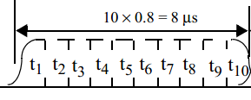
S_{-26,26} = sqrt(1/2)
{0,0,1+j,0,0,0,-1-j,0,0,0,1+j,0,0,0,-1-j,0,0,0,-1-j,0,0,0,1+j,0,0,0,
0,0,0,0,-1-j,0,0,0,-1-j,0,0,0,1+j,0,0,0,1+j, 0,0,0,1+j, 0,0,0,1+j,0,0}

L-LTF
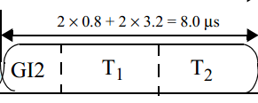
L_{-26,26} =
{1,1,-1,-1,1,1,-1,1,-1,1,1,1,1,1,1,-1,-1,1,1,-1,1,-1,1,1,1,1,0,
1,-1,-1,1,1,-1,1,-1,1,-1,-1,-1,-1,-1,1,1,-1,-1,1,-1,1,-1,1,1,1,1}
The lower subcarrier is at -26 ~ -1.
The upper subcarrier is at 1 ~ 26.

L_SIG
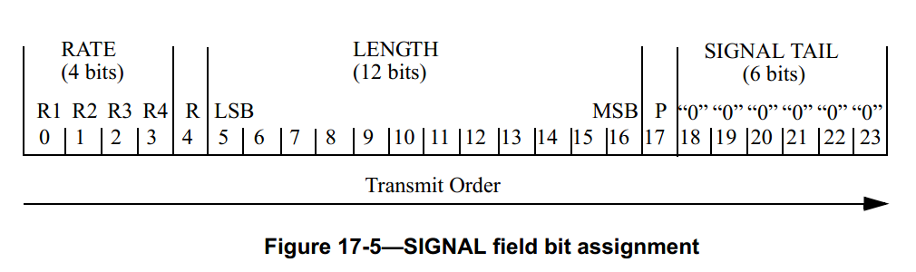
In this symbol, four of the subcarriers are dedicated to pilot signals at -21, -7, 7 and 21.
The SIG symbol contains 48 complex numbers allocated in frequency, as follows:
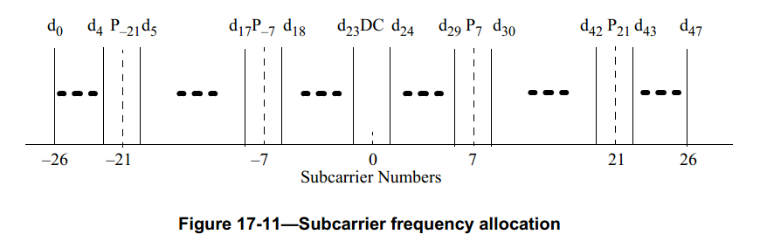

Data
In data field, four of the subcarriers are dedicated to pilot signals at -21, -7, 7 and 21.
The each symbol contains 48 complex numbers allocated in frequency like L-SIG.

CH_OFFSET
CH_OFF_20: the subcarrier frequency allocation as follows:
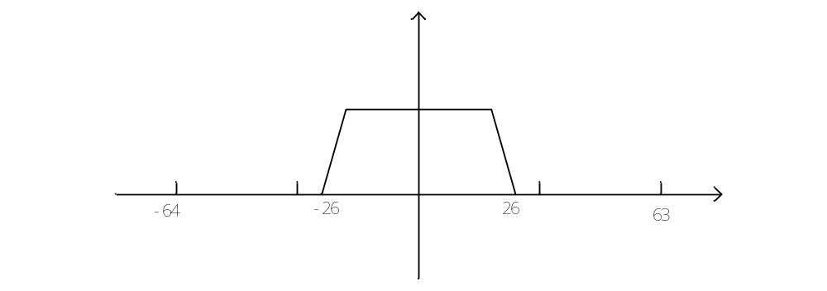
Pilot signal: -21, -7, 7, 21
Valid data: -26 ~ -22, -20 ~ -8, -6 ~ -1, 1 ~ 6, 8 ~ 20, 22 ~ 26

CH_OFF_20U: OFDM transmits in the upper 20 MHz of a 40 MHz channel, the subcarrier frequency allocation as follows:
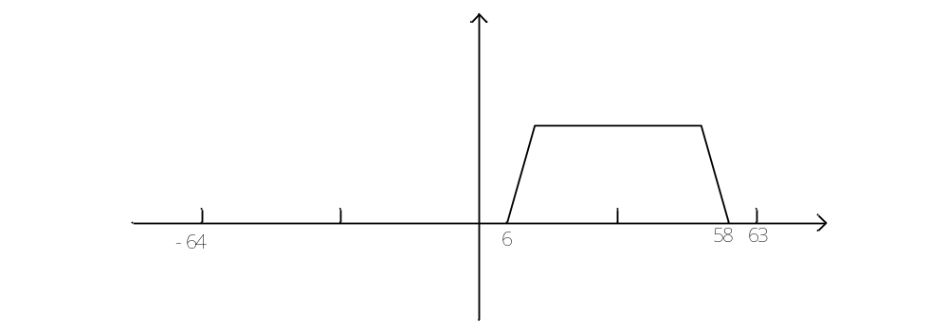
Pilot signal: 11, 25, 39, 53
Valid data: 6 ~ 10, 12 ~ 24, 26 ~ 31, 33 ~ 38, 40 ~ 52, 54 ~ 58

CH_OFF_20L: OFDM transmits in the lower 20 MHz of a 40 MHz channel, the subcarrier frequency allocation as follows:
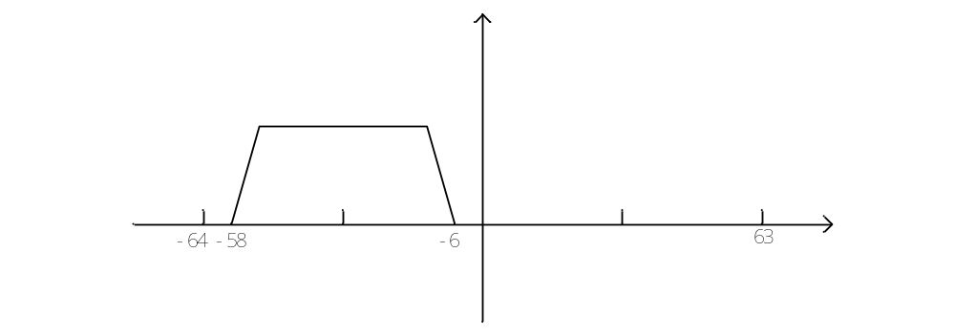
Pilot signal: -53, -39, -25, -11
Valid data: -58 ~ -54, -52 ~ -40, -38 ~ -33, -31 ~ -26, -24 ~ -12, -10 ~ -6

NON_HT_CBW40
The OFDM signal’s bandwidth is 40M including CH_OFF_40. The STA operates in a 40MHz channel composed of two adjacent 20MHz channels. The upper channel is rotated by +90º relative to the lower channel.

L-STF
S_{-58,58} = sqrt(1/2)
{0,0,1+j,0,0,0,-1-j,0,0,0,1+j,0,0,0,-1-j,0,0,0,-1-j,0,0,0,1+j,0,0,0,
0,0,0,0,-1-j,0,0,0,-1-j,0,0,0,1+j,0,0,0,1+j, 0,0,0,1+j, 0,0,0,1+j,0,0,0,0,0,
0,0,0,0,0,0,0,0,0,0,1+j,0,0,0,-1-j,0,0,0,1+j,0,0,0,-1-j,0,0,0,-1-j,0,0,0,1+j,
0,0,0,0,0,0,0,-1-j,0,0,0,-1-j,0,0,0,1+j,0,0,0,1+j, 0,0,0,1+j, 0,0,0,1+j,0,0,}

The upper subcarriers 6~58 are rotating by +90º when it is transmitted

L-LTF
L_{-58,58} =
{1,1,-1,-1,1,1,-1,1,-1,1,1,1,1,1,1,-1,-1,1,1,-1,1,-1,1,1,1,1,0,
1,-1,-1,1,1,-1,1,-1,1,-1,-1,-1,-1,-1,1,1,-1,-1,1,-1,1,-1,1,1,1,1,0,0,0,0,0,
0,0,0,0,0,0,1,1,-1,-1,1,1,-1,1,-1,1,1,1,1,1,1,-1,-1,1,1,-1,1,-1,1,1,1,1,0,
1,-1,-1,1,1,-1,1,-1,1,-1,-1,-1,-1,-1,1,1,-1,-1,1,-1,1,-1,1,1,1,1}
The upper subcarriers 6~58 are rotating by +90º when it is transmitted

L-SIG
The lower channel is the same as 20MHz, the upper channel is rotated by +90º relative to the lower channel

CH_OFFSET
CH_OFF_40: Frequency allocation as follows:
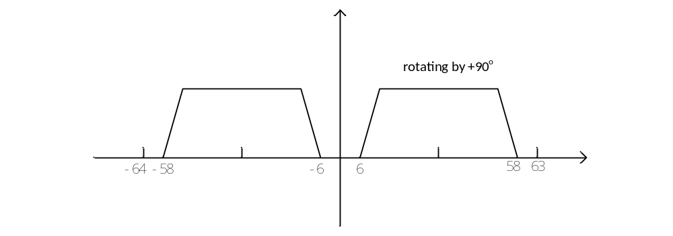
Pilot signal: -53, -39, -25, -11, 11, 25, 39, 53
Valid data: -58 ~ -54, -52 ~ -40, -38 ~ -33, -31 ~ -26, -24 ~ -12, -10 ~ -6, 6 ~ 10, 12 ~ 24, 26 ~ 31, 33 ~ 38, 40 ~ 52, 54 ~ 58

HT

HT_CBW20
The OFDM signal’s bandwidth is 20M including CH_OFF_20, CH_OFF_20U and CH_OFF_20L

HT_SIG
The HT_SIG is composed of two part symbols, HT-SIG1 and HT-SIG2, each containing 4 pilot signals and 48 complex numbers allocated in frequency like L-SIG.
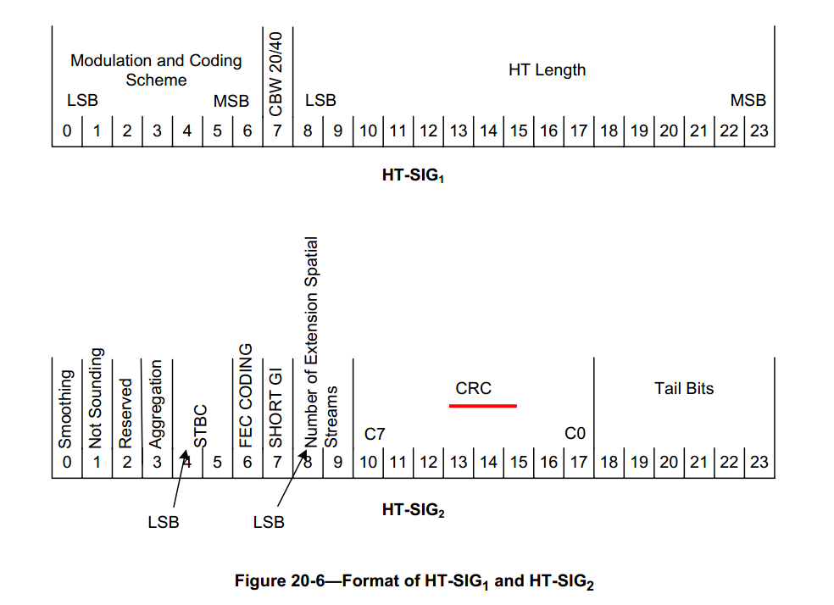
The constellation of the HT-SIG data tones is rotated by 90º relative to the L-SIG.
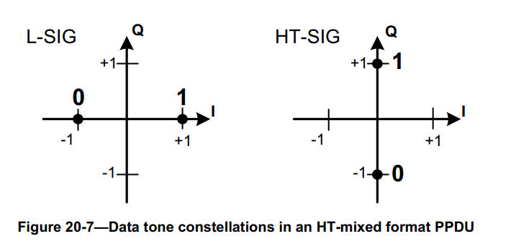

HT-STF
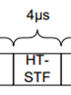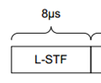
The duration time of HT-STF is half of L-STF, 4us

S_{-28,28} = sqrt(1/2)
{0,0, LSTF ,0,0}

HT-LTF
The HT-LTF portion has one or two parts. The first part consists of one, two, or four HT-LTFs that are necessary for demodulation of the HT-Data portion of the PPDU. These HT-LTFs are referred to as HT-DLTFs. The optional second part consists of zero, one, two, or four HT-LTFs that may be used to sound extra spatial dimensions of the MIMO channel that are not utilized by the HT-Data portion of the PPDU, These HT-LTFs are referred to as HT-ELTFs.

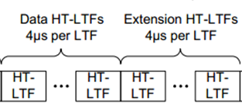
L_{-28,28} = { 1,1, LLTF , -1,-1 }
The lower subcarrier is at -28 ~ -1.
The upper subcarrier is at 1 ~ 28.
The number of symbol of HT-LTF N_{HTLTF} = N_{HTDLTF} + N_{HTELTF}

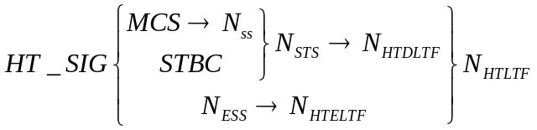
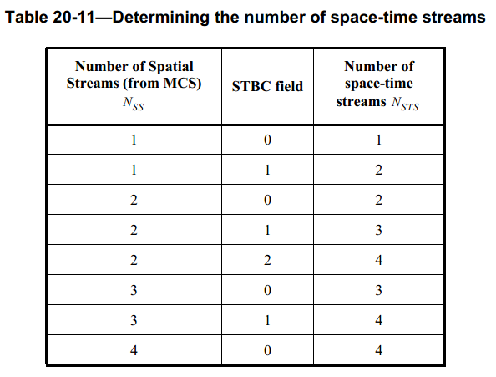
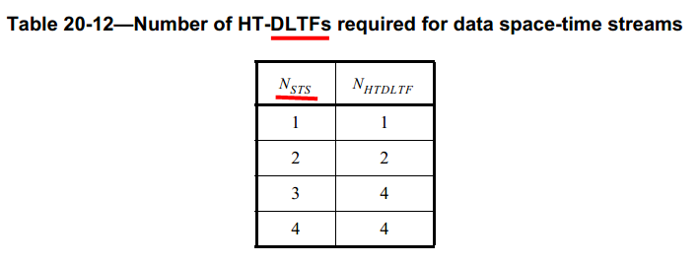
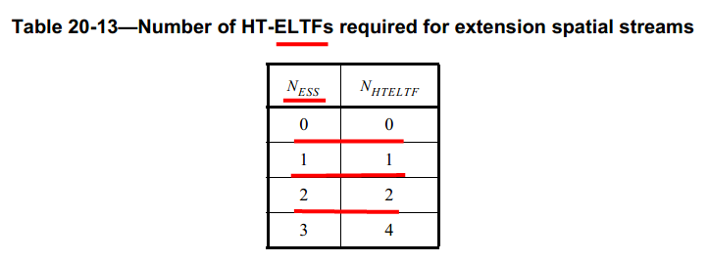
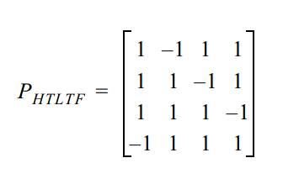

Data
In data field, four of the subcarriers are dedicated to pilot signals at -21, -7, 7 and 21.
The each symbol contains 52 complex numbers allocated in frequency as follow:
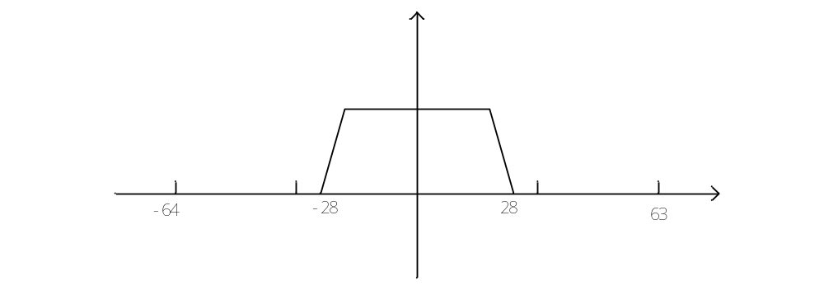
Pilot signal: -21, -7, 7, 21
Valid data: -28 ~ -22, -20 ~ -8, -6 ~ -1, 1 ~ 6, 8 ~ 20, 22 ~ 28

CH_OFFSET
CH_OFF_20: the subcarrier frequency allocation for data field as follows:
Pilot signal: -21, -7, 7, 21
Valid data: -28 ~ -22, -20 ~ -8, -6 ~ -1, 1 ~ 6, 8 ~ 20, 22 ~ 28

CH_OFF_20U: OFDM transmits in the upper 20 MHz of a 40 MHz channel, the subcarrier frequency allocation for data field as follows:
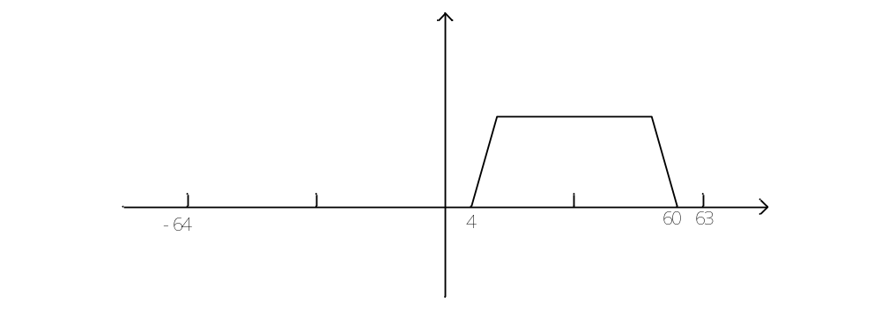
Pilot signal: 11, 25, 39, 53
Valid data: 4 ~ 10, 12 ~ 24, 26 ~ 31, 33 ~ 38, 40 ~ 52, 54 ~ 60

CH_OFF_20L: OFDM transmits in the lower 20 MHz of a 40 MHz channel, the subcarrier frequency allocation for data field as follows:
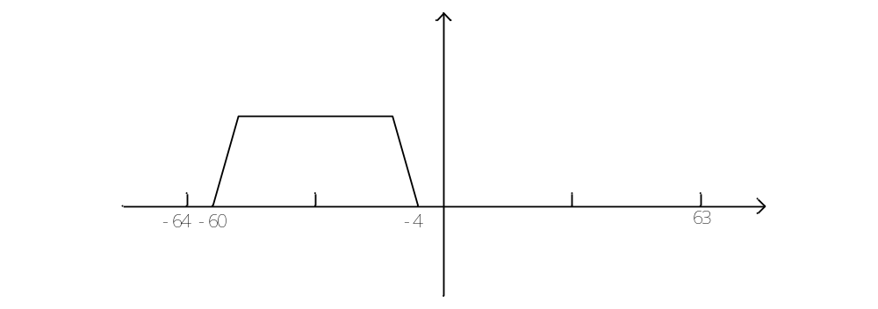
Pilot signal: -53, -39, -25, -11
Valid data: -60 ~ -54, -52 ~ -40, -38 ~ -33, -31 ~ -26, -24 ~ -12, -10 ~ -4

HT_CBW40
The OFDM signal’s bandwidth is 40M including CH_OFF_40. The STA operates in a 40MHz channel composed of two adjacent 20MHz channels. The upper channel is rotated by +90º relative to the lower channel.

HT-STF
S_{-58,58} = sqrt(1/2)
{0,0,1+j,0,0,0,-1-j,0,0,0,1+j,0,0,0,-1-j,0,0,0,-1-j,0,0,0,1+j,0,0,0,
0,0,0,0,-1-j,0,0,0,-1-j,0,0,0,1+j,0,0,0,1+j, 0,0,0,1+j, 0,0,0,1+j,0,0,0,0,0,
0,0,0,0,0,0,0,0,0,0,1+j,0,0,0,-1-j,0,0,0,1+j,0,0,0,-1-j,0,0,0,-1-j,0,0,0,1+j,
0,0,0,0,0,0,0,-1-j,0,0,0,-1-j,0,0,0,1+j,0,0,0,1+j, 0,0,0,1+j, 0,0,0,1+j,0,0}
The upper subcarriers are rotating by +90º when it is transmitted

HT-LTF
L_{-58,58} =
{1,1,-1,-1,1,1,-1,1,-1,1,1,1,1,1,1,-1,-1,1,1,-1,1,-1,1,1,1,1,1,
1,-1,-1,1,1,-1,1,-1,1,-1,-1,-1,-1,-1,1,1,-1,-1,1,-1,1,-1,1,1,1,1,-1,-1,-1,1,0,
0,0,-1,1,-1,1,1,-1,-1,1,1,-1,1,-1,1,1,1,1,1,1,-1,-1,1,1,-1,1,-1,1,1,1,1,1,
1,-1,-1,1,1,-1,1,-1,1,-1,-1,-1,-1,-1,1,1,-1,-1,1,-1,1,-1,1,1,1,1}
The upper subcarriers are rotating by +90º when it is transmitted
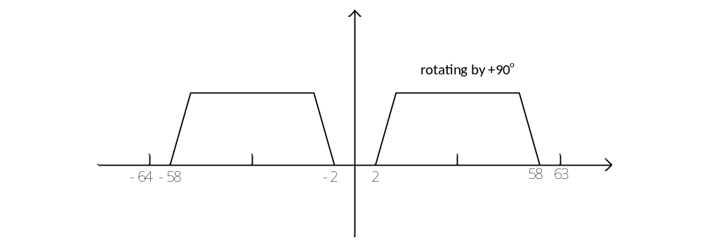

HT-SIG
The lower channel is the same as 20MHz, the upper channel is rotated by +90º relative to the lower channel
Frequency allocation as follows:
Pilot signal: -53, -39, -25, -11, 11, 25, 39, 53
Valid data: -58 ~ -54, -52 ~ -40, -38 ~ -33, -31 ~ -26, -24 ~ -12, -10 ~ -6, 6 ~ 10, 12 ~ 24, 26 ~ 31, 33 ~ 38, 40 ~ 52, 54 ~ 58

Data
In data field, six of the subcarriers are dedicated to pilot signals at -53, -25, -11, 11, 25 and 53
The each symbol contains 108 complex numbers allocated in frequency as follow:
Pilot signal: -53, -25, -11, 11, 25, 53
Valid data: -58 ~ -54, -52 ~ -26, -24 ~ -12, -10 ~ -2, 2 ~ 10, 12 ~ 24, 26 ~ 52, 54 ~ 58

MCS 32
HT_SIG, HT_STF, HT_LTF is the same as HT format.
But the data filed is the same as NON_HT format including 20M and 40M.

